Alexander Baldree
10/01/26
Module 10.2 Assignment
CSD440

GitHub Link:
https://github.com/Panda-Alex21687/CSD440

Full Form JSON:
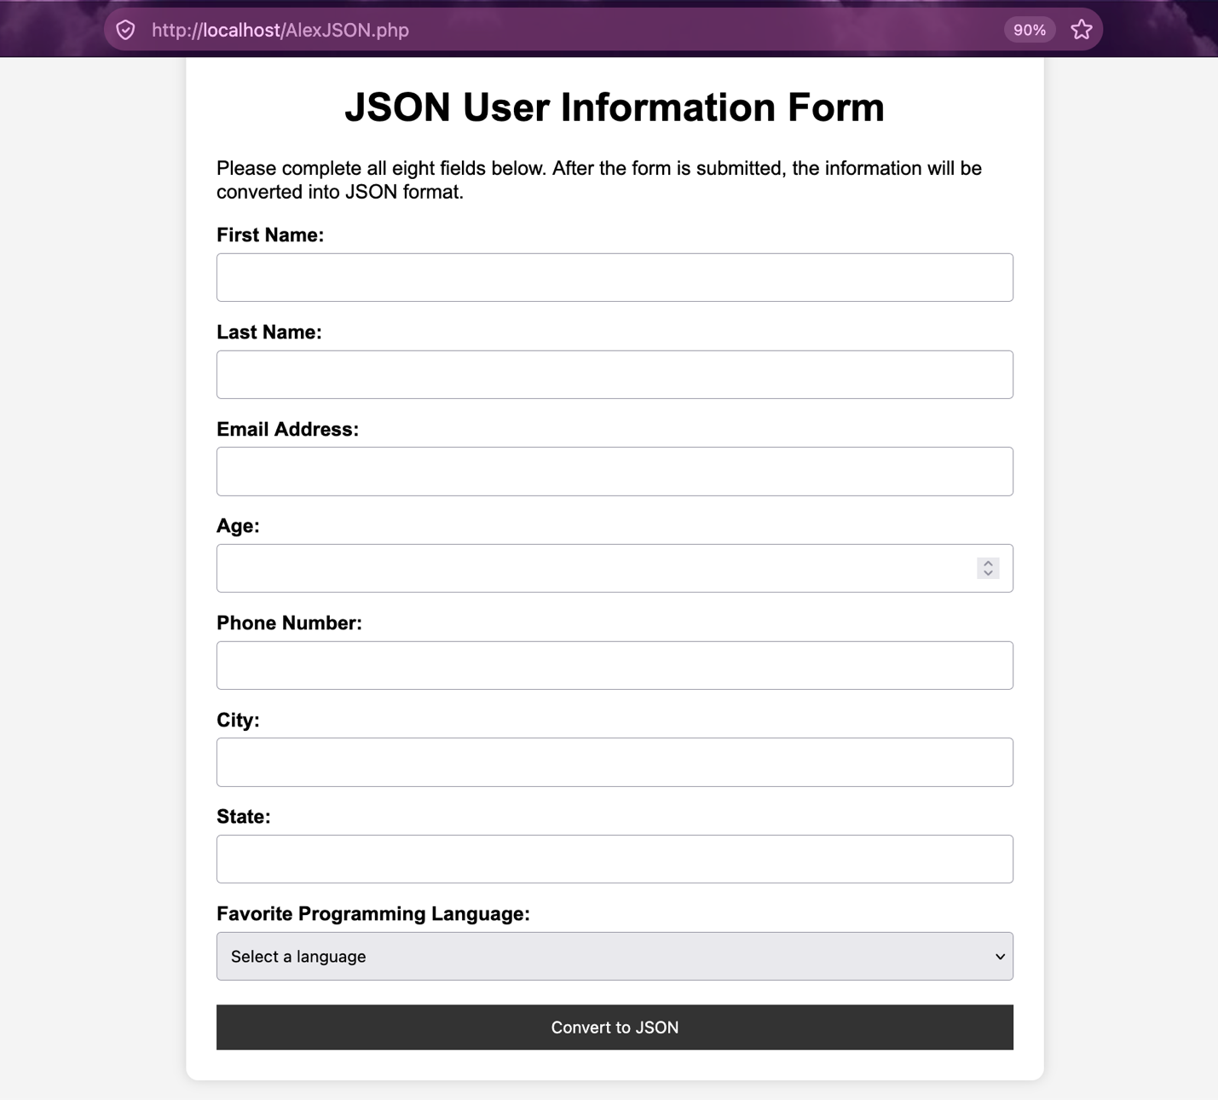
Form Filled Out Fully:
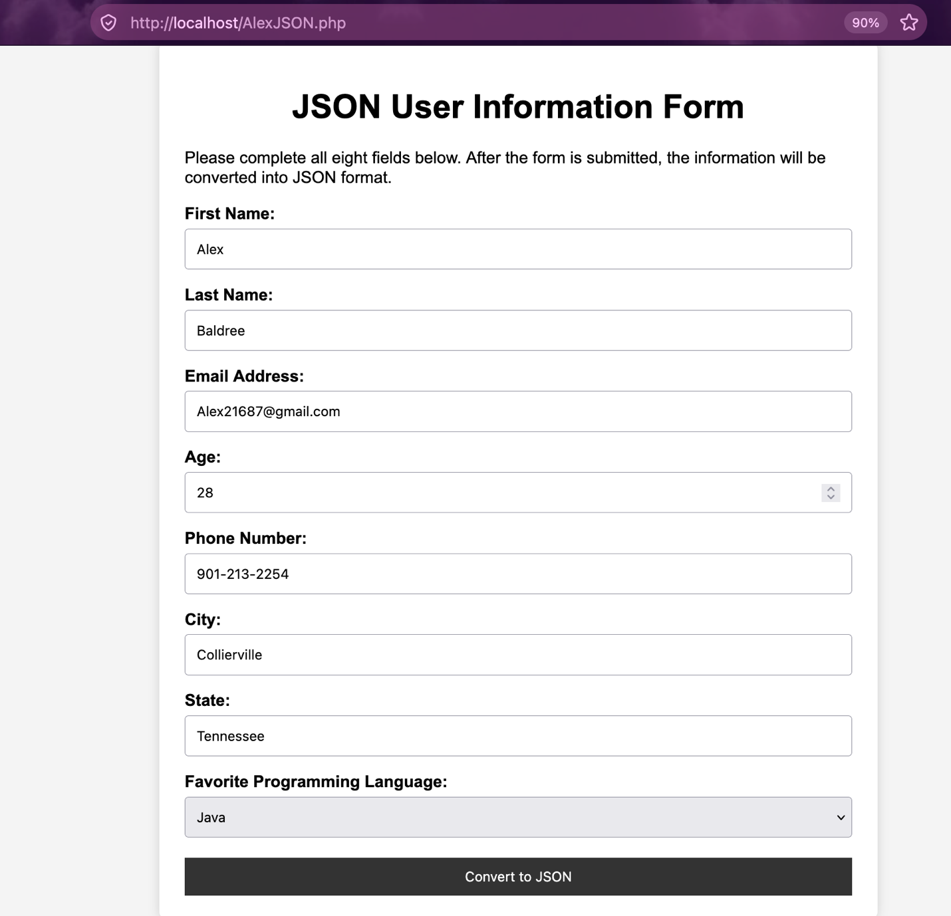

Successful JSON Output:
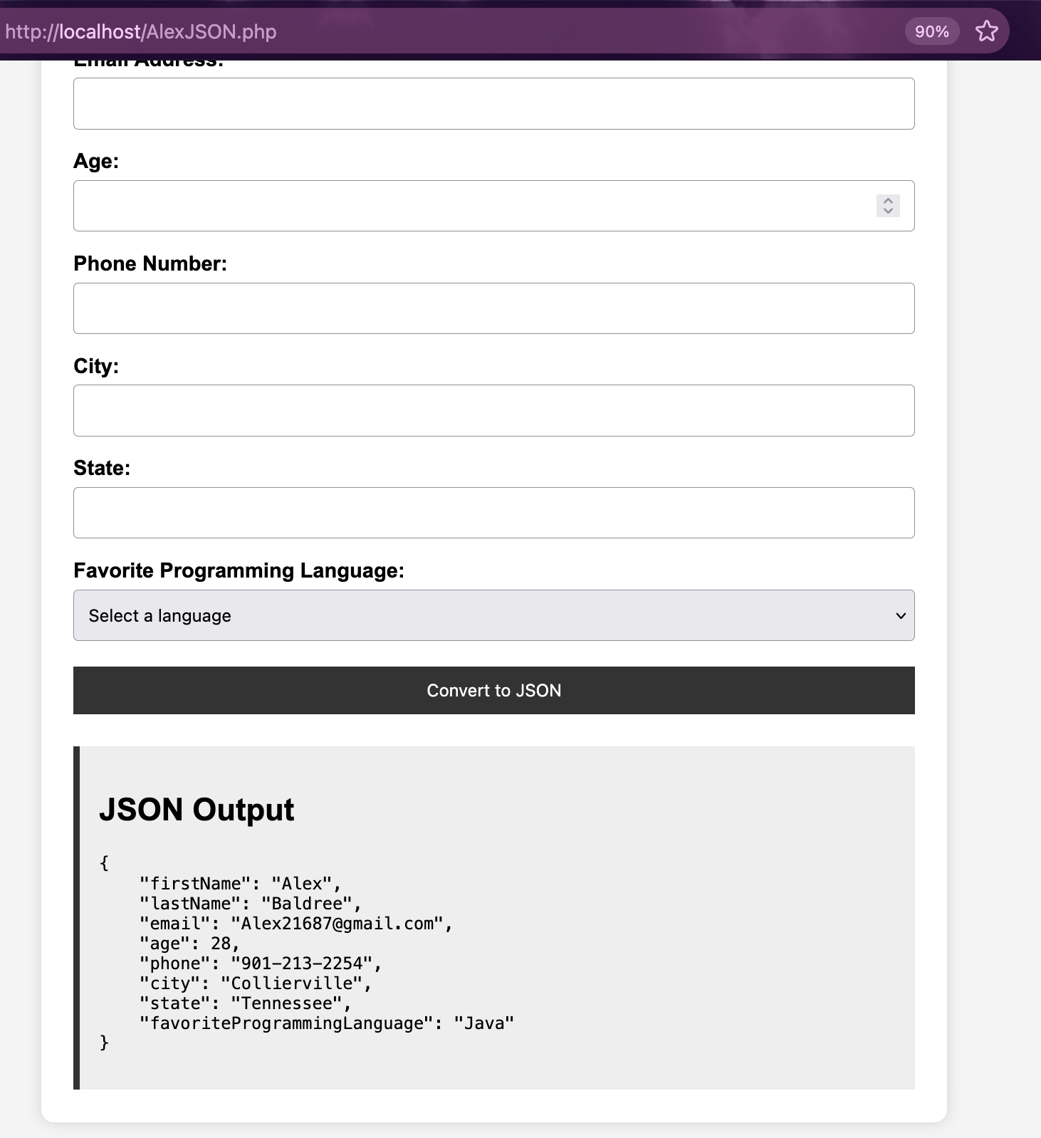

Error Handling Test:
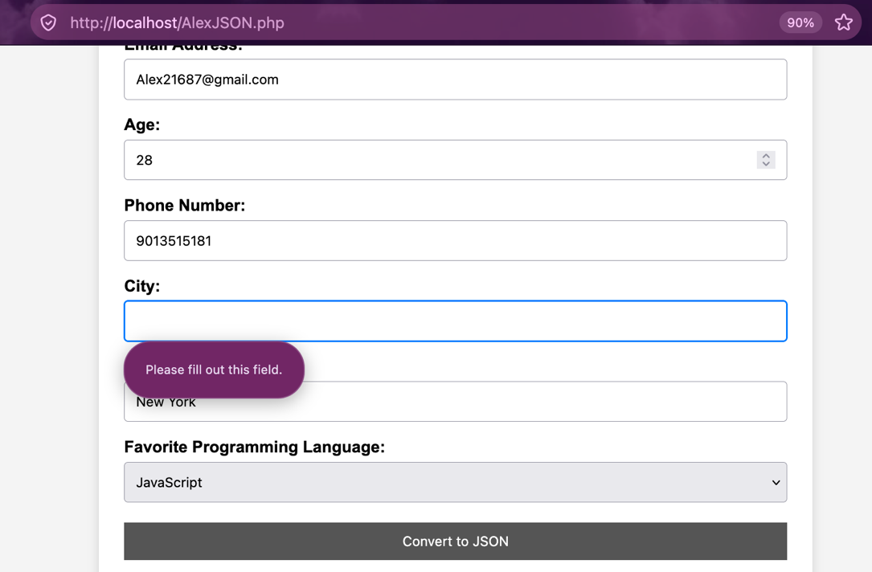

PHP in Visual Studio Code:
